

Name: Husam Ali Abdalla Nour
PRN: 25070122086
Branch: CSE (2025-29)
Semester: 3

Subject: Programming with Java

ASSIGNMENT No.: 5
TITLE: :Develop a Java application demonstrating the use of ArrayList, Vector, and StringBuffer for dynamic data storage, management, and string manipulation.

Problem Statement:

Develop a Java application demonstrating the use of ArrayList, Vector, and StringBuffer for dynamic data storage, management, and string manipulation.

Learning Objectives:

To implement dynamic data storage and string manipulation using ArrayList, Vector, and StringBuffer.

Theory:

ArrayList and Vector are dynamic array implementations provided by the Java Collections Framework. ArrayList offers faster performance in single-threaded applications, whereas Vector provides synchronized operations for thread safety. StringBuffer is a mutable sequence of characters that allows efficient string modification without creating new objects. These classes are commonly used in applications requiring dynamic memory allocation and efficient string processing.
Outcomes:
ArrayList, Vector, and StringBuffer enable efficient dynamic data storage and string manipulation, allowing flexible addition, removal, and management of data without fixed size constraints.

public class JAVA_EXP_5 { public static void main(String[] args) {

ArrayList<String> arrayList = new ArrayList<>(); arrayList.add("Apple"); arrayList.add("Banana");
System.out.println("ArrayList: " + arrayList);

Vector<String> vector = new Vector<>(); vector.add("Car"); vector.add("Bike");
System.out.println("Vector: " + vector);

StringBuffer sb = new StringBuffer(); sb.append("Hello"); sb.append(" World"); sb.insert(5, ",");
System.out.println("StringBuffer: " + sb); }

}

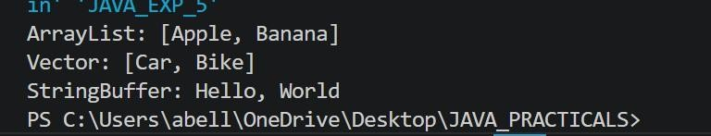

Conclusion:

This assignment demonstrates the effective use of ArrayList, Vector, and StringBuffer for dynamic data storage and string manipulation in Java. ArrayList provides fast, resizable storage for singlethreaded applications, while Vector offers synchronized, thread-safe operations. StringBuffer enables efficient, mutable string handling without creating multiple objects.
Exercise:

- Create a To-Do List application using ArrayList to store tasks and StringBuffer to display tasks.
import java.util.ArrayList; public class JAVA_EXP_5{
ArrayList<String> tasks = new ArrayList<>();
void addTask(String task){ tasks.add(task);
}
void removeTask(String task){ tasks.remove(task);

}
void displayTasks(){
StringBuffer sb = new StringBuffer(); sb.append("To-Do List: \n"); for (int i = 0; i < tasks.size(); i++){ sb.append((i+1) + ". " + tasks.get(i) + "\n"); }
System.out.println(sb);
}
public static void main(String[] args) { JAVA_EXP_5 list = new JAVA_EXP_5();
list.addTask("Buy groceries"); list.addTask("Complete Java assignment"); list.addTask("Read a book"); list.displayTasks();
list.removeTask("Read a book");
System.out.println("After removing a task: "); list.displayTasks();

}
}
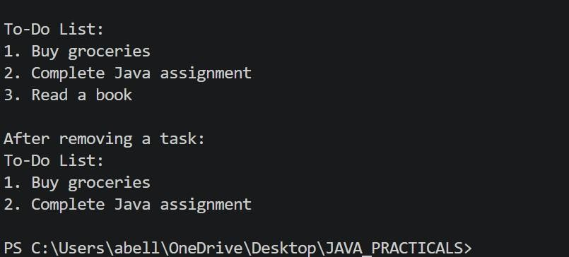

- Create a Student Course Registration System using ArrayList to store the list of courses registered by a student and StringBuffer to generate and display the registered course list.
The application should allow users to add, remove, and view registered courses.

import java.util.ArrayList; public class JAVA_EXP_5{
ArrayList<String> courses = new ArrayList<>(); ;
void addCourse(String course) { courses.add(course);
}
void removeCourse(String course) { courses.remove(course);
}
void viewCourses() {
StringBuffer sb = new StringBuffer(); sb.append("Registered Courses:\n"); for (int i = 0; i < courses.size(); i++) { sb.append((i + 1) + ". " + courses.get(i) + "\n");
}
System.out.println(sb);
}
public static void main(String[] args) {
JAVA_EXP_5 reg = new JAVA_EXP_5();
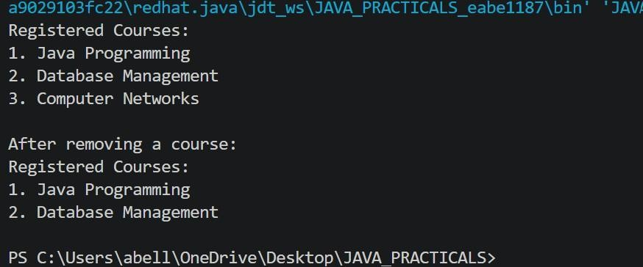

reg
.
addCourse
(
"Java

Programming"
)
;

reg
.
addCourse
(
"Database

Management"
)
;
reg
.
addCourse
(
"Computer Networks"
)
;

reg
.
viewCourses
()
;
reg
.
removeCourse
(
"Computer

Networks"
)
;

System
.
out
.
println
(
"After

removing

a

course:"
)
;

reg
.
viewCourses
()
;

}

}

